- Create a shell script to print the HTTP error code of guvi.in & print, the success/failure message based on the error code response

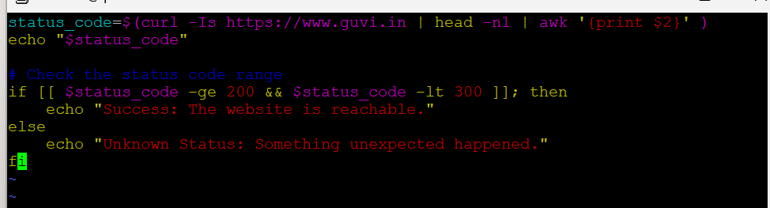

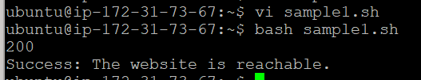

2. Given a file, replace all occurrence of the word give with learning from 5th line till the end in only those lines that contain the word welcome

